Enhancement Three Narrative: Databases
Dylan Kimball
CS-499
Brooke Goggin

Artifact Overview
The artifact that I have chosen to enhance for category three: Database, is a simple java program that I created back in June 2022 for the CS-250 Software Development Lifecycle class. This program takes some hard coded data and creates a small slide show window on the user’s computer that displays travel destinations. The user is able to see a destination’s title, image, and a small description, and they can either click next or previous to see another destination.
I decided to include this artifact as Java is a language that is used throughout multiple different fields within the computer science industry. This artifact and the enhancements showcase my abilities in the Java language. My goal for this project was to make a full website to display the destination information which is something I have very little experience with. In selecting this project, I am also showcasing my ability to learn new concepts, implement new knowledge, utilizing different libraries and software’s, full-stack development skills, and take a simple program and expand on it to produce a new product that meets a different outcome.
Enhancements
The original program is quite simple and only consists of a small amount of code that allows the destination data to be displayed on a new window that was created. I enhanced the code by rebuilding it from the ground up in order to create a functional website that utilizes a NoSQL MongoDB database. I created a MongoDB database in the cloud utilizing MongoDB Atlas to ensure that the database can be accessed by authenticated users no matter the device (See figure 2 and 3 below). The website was created through utilizing a Spring Boot project with a Rest CRUD API which implements Spring security, Maven dependencies, MongoDB support, and thymeleaf functionality. The website opens up to the home page which takes the destination data that is stored in the MongoDB database and uses CSS Flexbox to dynamically display the information in card format on the website (See Figure 1 below). A normal user can only view this information and all other pages are protected through requiring an authenticated login.
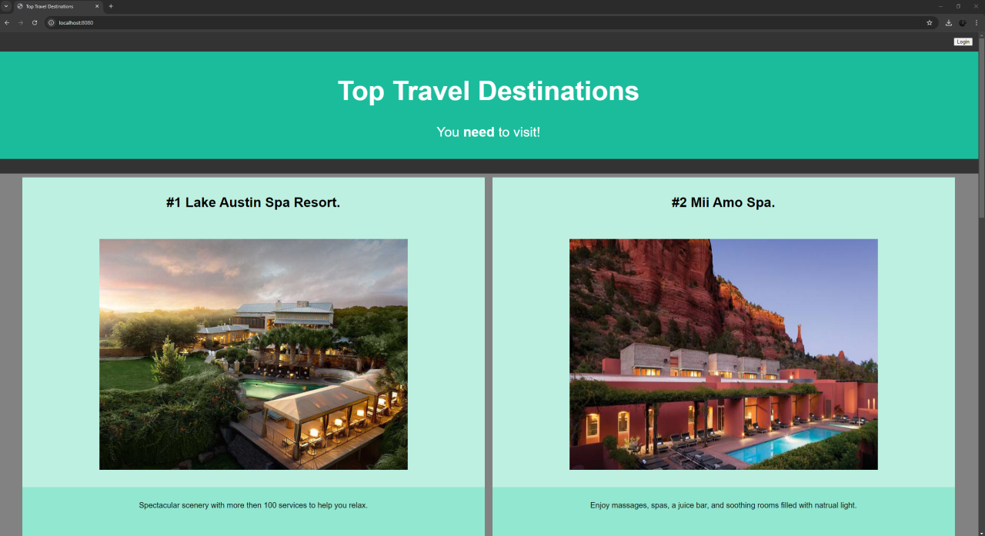
(Figure 1 - Website Homepage)
While a normal user can only view information, an admin with a login can login into the website which will bring them to the admin page. Here an admin can either add, modify, or delete a destination from the database through the website. All other pages other than the main home page required an admin login to access, if you try to access these pages without authentication you will be routed to the login page. There is no button to register a login as only admins can access this website, so there would be a dedicated person in the company that would add a user into the authenticated user database. All passwords in the database are encrypted using BCrypt in order to enhance the website’s security. On the admin page, there is a logout button which will fully logout any authenticated user that is logged in.
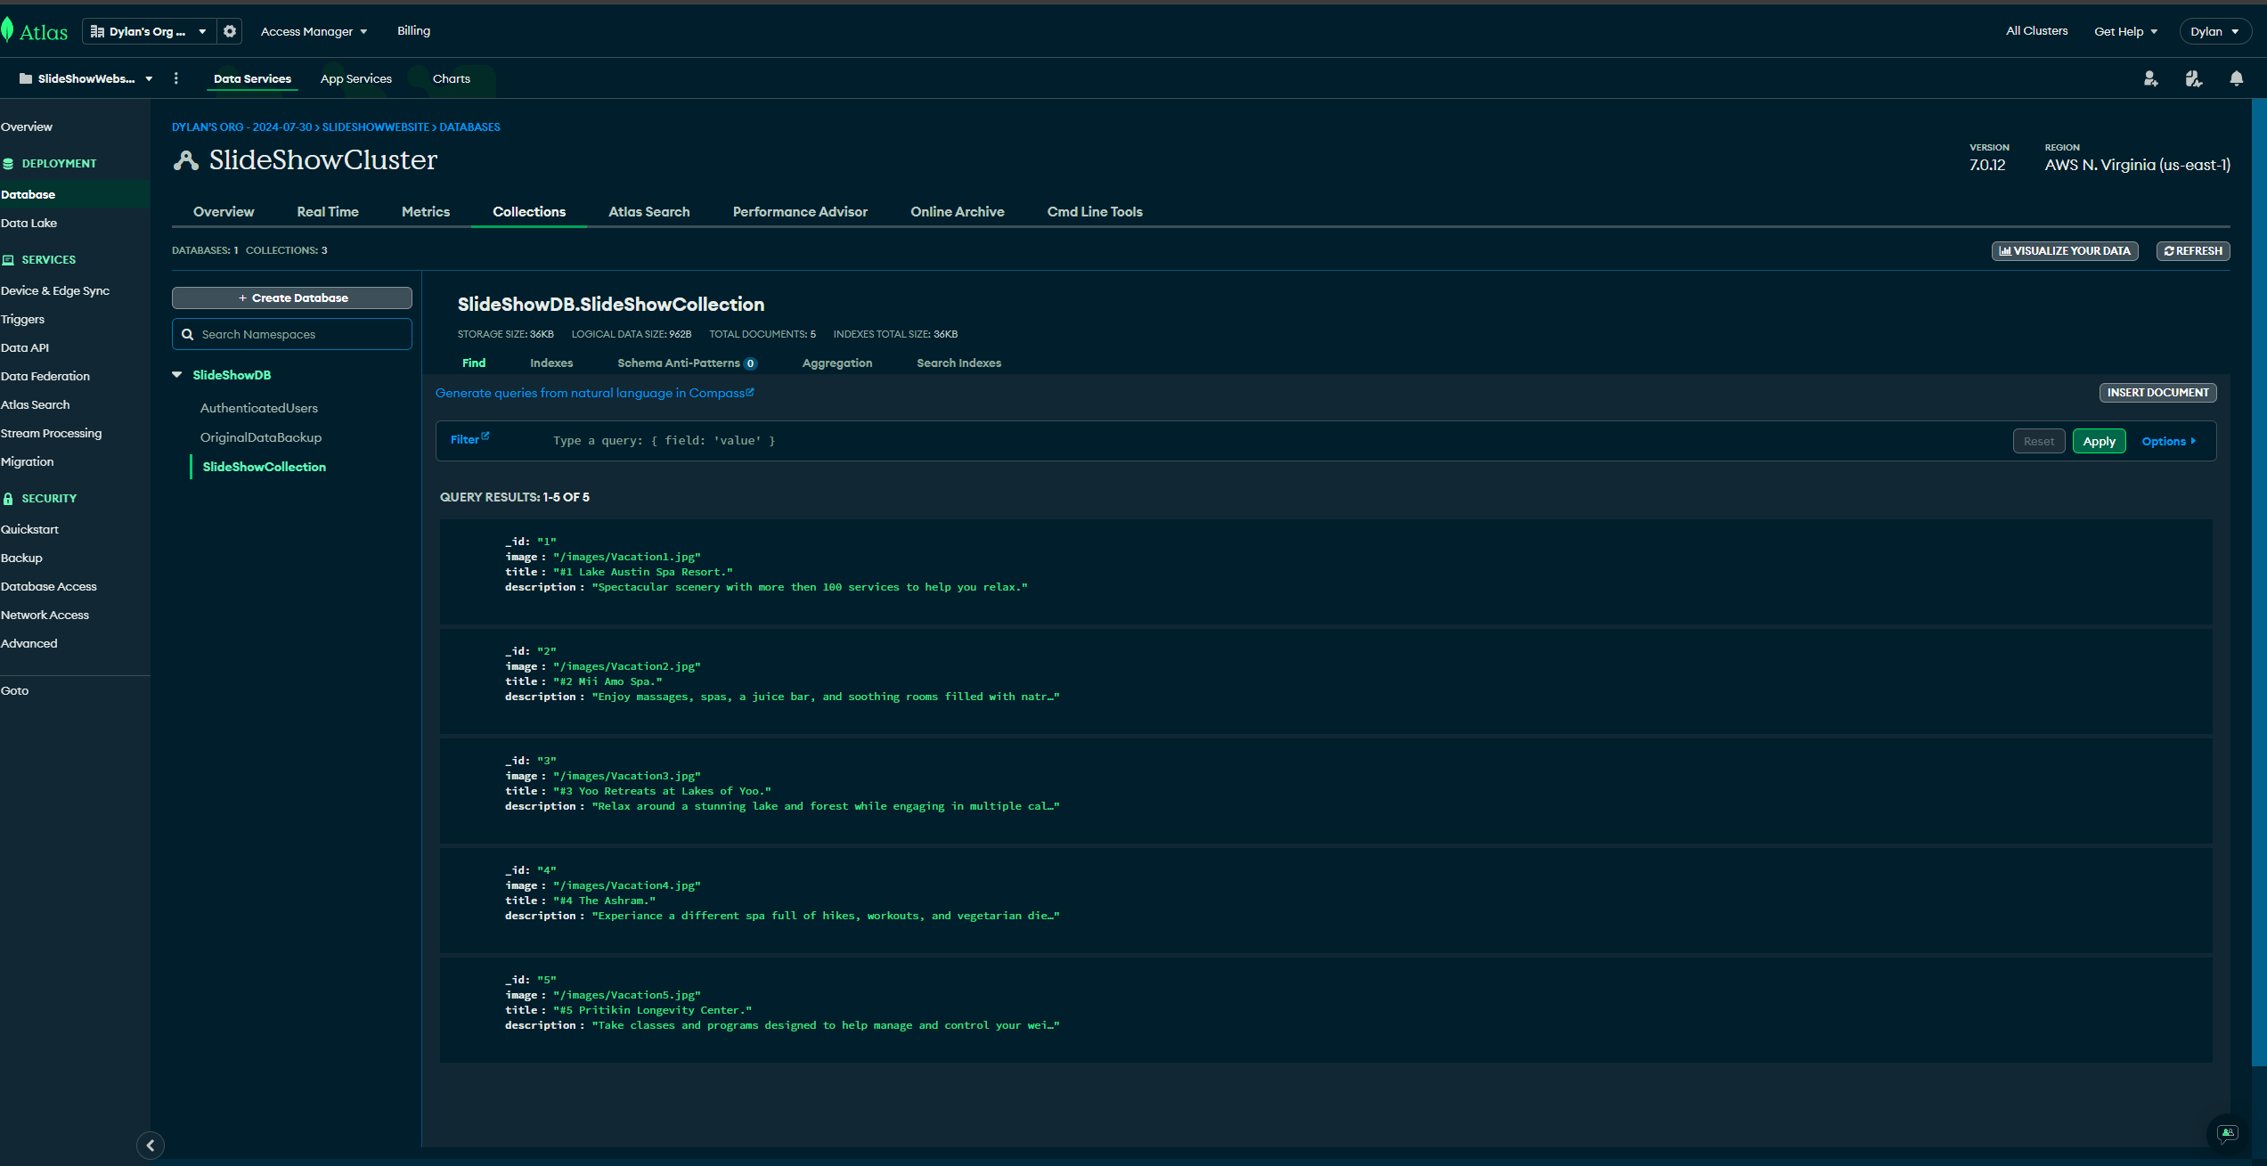
(Figure 2 - Destinations collection in database)

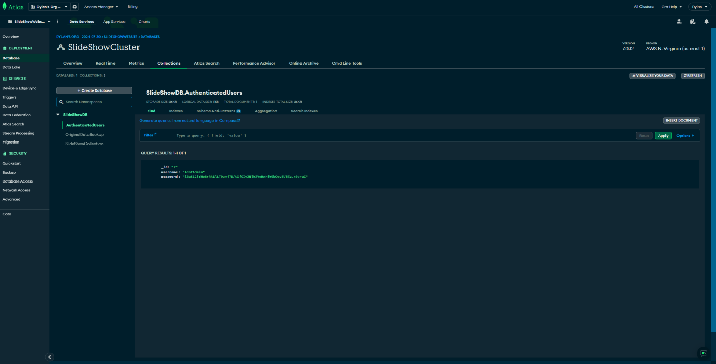
(Figure 3 - Authenticated Users collection in database with encrypted password)

Course Objectives
I have met the two course objects I set out to meet with this enhancement. The first course object I met with the finished enhancement is below:
- Employ strategies for building collaborative environments that enable diverse audiences to support organizational decision-making in the field of computer science.
The website’s connection to the database makes it simple for an authorized user to add, delete, or modify records on this database. There is no experience needed and this allows normal users to view the database while the admins can tailor the destinations to suit the user’s needs, and if needed an experienced person can easily modify the program’s code or database to make any necessary changes. This website allows different people of different skills sets and experience to work together and improve the website. The second and final course objective I have met through this enhancement is the following:
- Develop a security mindset that anticipates adversarial exploits in software architecture and designs to expose potential vulnerabilities, mitigate design flaws, and ensure privacy and enhanced security of data and resources.
I have implemented multiple security features into this website in order to enhance the security of both the website and the database. Starting with the database, it was built using MongoDB atlas to utilize both the cloud functionality and security features offered by this program. When it comes to the website, all pages other than the main home page require authentication to access, if a user attempts to access a page without this authentication they will be routed to the login page. Authenticated user logins can only be added by an authorized individual into the database to avoid any unwanted people registering for the website. All passwords in the database are encrypted using Bcrypt to ensure that passwords are only known by the individuals who are using them.
Reflection and Challenges
This enhancement is the one that I was most nervous about due to how little I knew about website development. I have worked with full-stack development in a couple of classes throughout my SNHU career, however I did not retain a lot of the information and these classes didn’t allow for much freedom to really play around and understand what I was doing. The largest hurtle by far for the enhancement was just learning each step of creating a website. I started with the database which I knew I wanted to be on the cloud to ensure more security than my system could provide while also making it accessible from whatever device needed it. I created my database through MongoDB Atlas and added each travel destination as a record. My next step was to create the HTML files that would display and style the website, this part was actually really fun as I learned about things like thymeleaf, grid formats, flexbox formats, etc. Once I had the styles down I worked on creating the button functionality to add, modify, and delete records. Creating the functions to add, modify and delete from the database was actually straightforward and easy, the problem I faced was utilizing the HTML file to gather the information and submit it to the function that would actually connect to the database. I was able to get a good functional product after some more research and testing.
Just like everything else with the enhancement, I knew absolutely nothing about security in web applications, so researched a lot and tested multiple different options to help me understand the concepts and implement them in my application. I started by including spring security in my dependencies and setting up the configuration to use my custom login page and allow the home page while resting all other pages to require authentication. Next I spent a while testing different authentication methods, debugging, testing again, debugging more, until I was finally able to connect to the database and fully authenticate a user. I felt so great after getting this final step to work, and I proceeded to test the full website, read through my code, update comments, and just polished everything up.

This entire process was fascinating to me as I researched a lot about website creation, and I was able to learn so much in this short amount of time. I faced a multitude challenges during this process as I had to try multiple different things to figure what worked, how I improve it, etc., but because I had the opportunity to mess around and figure out what did what, I’ve been able to learn so much more and actually retain that information. When I started this project, I knew absolutely nothing about what software was needed or the code that went into full-stack development. Now I feel much more confident about what I have been able to achieve, and I would feel confident building another website utilizing the knowledge I’ve gained. Overall, I was nervous starting this project, but I have gained so much knowledge, skills, and confidence throughout the process.

